Crime Discussion Questions
Name
Institution affiliation
Date

Burglary Discussion Questions
- Explain the distinction between the crime of burglary and the crime of robbery
Burglary is a crime that involves persons making an illegal entry to a structure such as a building with intention to steal property. It involves any form of illegal entry that leads to stealing property, whether successfully or unsuccessfully and, will be charged under the burglary offense laws (Lyman, 2016). On the other hand, robbery is a crime where the perpetrator applied fear or force to acquire something from the victim of the act. Robbery is further connected to forcefully take something from another person with a permanent effect on keeping it from them.
- Identify the elements of burglary and the evidence needed to support each element for a conviction for the crime
The burglary crimes are characterized by the following crime elements that include;
Element | Supportive evidence
Illegal entry to a building home or any other protected structure | Live video evidence, fingerprints, or testimony by a witness
The building entered that may include a business or home | police investigators must visit the scene of the crime for proof of the existence
Intent to commit a felony | Actual stealing evidence where the property is forcefully taken, fingerprints, verifiable witness evidence, or video footage (Lyman, 2016)
-Define burglary tools and identify five different examples.
A burglary tool is any form of an instrument, tool, or object that's applied, adapted, and designed to promote forceful entry to a building or those that are used to promote theft. Examples of the burglary tools include;
- Gloves, masks, and clothing utilized in hiding the fingerprints that would aid in tracing the criminal,
- Ropes utilized in climbing wars,
- Hammers, screwdrivers, and other hand tools for aiding in breaking doors and windows,
- Special devices and hacking codes applied to decode the modern automated locks to allow entry and,
- Explosives are used to break entry points.
- Identify and explain the five major methods of forceful safe entry.
Forceful safe entry can occur through different methods as applied by the perpetrator. First, they understand the mystery behind doors where tools and techniques are applied to unclick them and gain entry safely. Secondly, the use of social engineering techniques aids the buglers to gain entry and perform an easier undetected burglary effect (Lyman, 2016). Thirdly, the criminal can steal the entry locks such as smart cards and gain entry easily to a building to commit the crime. Fourthly, the modern locks that apply technology-based methods can be hacked, especially doors, to gain easy entry to a building. Lastly, the burglars may cooperate with the internal staff to commit the crime leading to easy access to the building.
-Identify at least three different ways how an investigator might prove that property found with a suspect is stolen.
The main ways applied to prove a property found is a stolen include (Lyman, 2016);
- Marching the unique identities of the stolen property with the clear records such as buying receipts and other proofs given by the victim that includes serial numbers,
- Failure of the suspect to prove where they sourced the property from,
- An attempt by a suspect to hide or conceal a property with any proper reason and,
- Possibility of property damage.
-Why are burglary clearance rates so low?
Clearance rates tend to be low due to several issues that affect the cases generally. First, the identification of relevant tools to investigate the crime make the police’s work difficult. There is low resource devotion towards the investigation processes (McManus et al., 2020). Secondly, when criminals have hidden key aspects that would make the evidence identifiable such as fingerprints and hidden faces, it becomes difficult to identify those making investigations difficult.
- What could be done to improve the clearance rates?
Improving the police effectiveness in clearance rates will require several factors to be addressed as a top priority. First, there is a need to enhance the collaboration between the involved officers, including detectives, crime scene experts, and patrol officers. Second, there is a need to include better training to promote the ability of the officers in the investigation to identify criminals. In this regard, the officers require mentorship to promote their adherence and understanding of agency standards and commitment to work (Lyman, 2016). Besides, there is a need to adopt more technological solutions to enhance the investigation process. For instance, the use of modern case management software will promote efficiency in clearance processes.
-What prevention techniques could the following burglary locations implement to reduce the opportunity of being burglarized?
 | Techniques to prevent burglary occurrence
i. Private homes | Install CCTV cameras, install alarms and hire security personnel if possible
ii. Businesses | Investing in less risky locations, Use CCTV cameras, hire security personnel, and install AI detective machines that detect the codes placed in unpaid-for items
iii. Commercial retail businesses | Use CCTV cameras to discourage burglary
iv. Storage facilities | Secure access locks that include both physical and advanced devices. They can include the use of human detective alarms, smart locks, and other technologically supported devices
- What role does physical evidence play in burglar investigations?
Physical evidence is an important part of a burglary crime and includes documents, property found, and the actual presence of the crime evidence. It's a form of direct evidence that gives the investigators direction and focus (Johnson, 2018). Hence, the evidence is applied to link suspects to the crime, and further investigation can be applied to find other facts to prove suspects' guilty of the burglary offense.
- Do you agree that burglary suspects should be convicted on circumstantial evidence?
Yes, I agree that it can apply circumstantial evidence in connection with a burglary suspect. However, circumstantial evidence is applicable when proofed and backed by several facts. For instance, if persons are found with crimes stolen during a burglary crime, it creates a major connection of the suspect. Therefore, once the premise is proved with enough facts, the court can draw the inference from the circumstantial evidence.
- What criteria (if any) should be used to make burglary arrests?
The main criteria used in making burglary areas include the following;
- Availed evidence that a suspect was at the place of crime where forceful entry happened and,
- Evidence that a suspect has property stolen at the burglary scene of the crime.
- How can stolen property be recovered from burglary cases if it is sold on the internet?
It's possible to recover the stolen items that are sold over the internet. However, one must have the correct records regarding the stolen items. For instance, the serial numbers, car identification numbers, and other unique details help locate the stolen items across the globe. It's much possible if a suspect is known and the platform applied. Hence, digital trackers will be applied to help in finding the buyer's location.

ID Theft Investigator Discussion Questions
- Explain your role in investigating ID theft cases.
ID theft identity is one of the most complicated aspects of crimes that the officers must investigate. The main role of an ID investigator is to aid the victims in identifying the criminal and safeguarding their accounts to prevent further manipulation (Gupta, Kalaimannan & Yoo, 2019). Generally, some identity thefts may be difficult; hence the prevention of further manipulations, especially of the credit cards are involved, is a key aspect the identity theft investigator is interested in preventing.
- Can you give some examples of cases you have investigated?
So far, I have investigated several cases involving identity theft. Unfortunately, most of the cases are yet to be concluded. For example, one of the cases involved the theft of smart lock keys where a perpetrator happens to be a friend to the victim and successfully stole the card and later committed a burglary crime at their workplace. The suspect was identified after investigating the victim's activities during the unfortunate day when the crime occurred (Lyman, 2016). The other example includes an ongoing case where s victim found goods bought using his credit card. The investigation is still in progress, and we are making utilization of finding the digital footprints that could link to the perpetrator.
- Can you show examples of some of the artifacts that you use as evidence in either your investigation or in court, such as Photographs, Credit reports, False or stolen identification cards, Affidavits, Surveillance video Other?
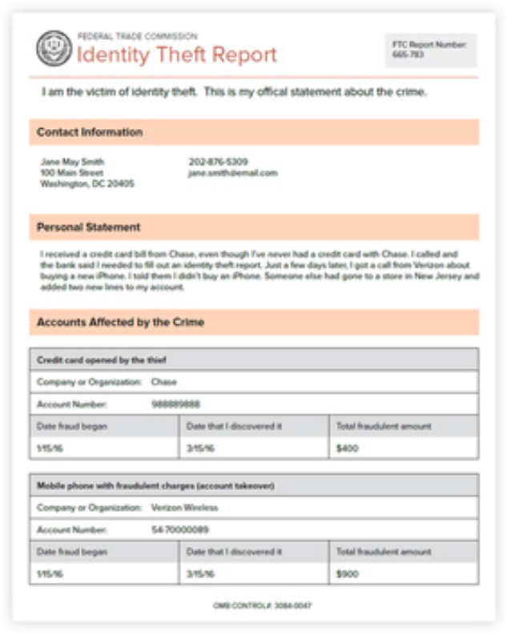
Figure 1: sample ID theft report
- What is the role of circumstantial evidence in ID theft investigations and prosecutions?
The circumstantial evidence is applicable when proofed and backed by several facts. For instance, if a suspect is found with a tool used to gain entry at the scene of the crime, then it creates a major connection (Blum, 2019). If identity theft is involved, the investigation has to explore and prove all other possibilities. In another instance, if a suspect is found to have possession of tools used in the crime scene, then the owners have to investigate whether the suspect or owner committed the crime.
- Can you comment on the ID theft clearance rates at your department?
The identity theft crimes at my department have been low. It's caused by a lack of ability to gather proof on the real perpetrators of the crime. It's my recommendation that more resources and expert training are needed to improve the situation.
- Have you experienced a false ID theft allegation from a “victim?” What were the motivations?
I have encountered a false identity allegation once in the past from a victim. The motive of the victim was to evade the prosecution for the crime committed. However, I identified the victim's falsehood aspect after failing to offer some of the requested information that included the home address and government issues photographic identity (Lyman, 2016). As a result, the unit department first investigates the victim, where officers acquired a search warrant from a court of law. The officers found all the stolen items at the victim's home.
- Do victims commonly over-estimate loss, exaggerate, or lie about a loss to increase the amount reported to financial institutions or insurance companies?
Yes, some of the victims have the tendency of overestimating the loss made. This is seen as a move to gain from the problem, especially when they expect a refund or insurance payment.
- What are the common procedures to investigate ID theft?
The common procedure during the investigation of identity theft includes the following process;
- A report is made detailing the victim's claim and includes making connections to their associated accounts, such as a bank in case of credit cards.
- Ensure that a victim has canceled any compromised accounts because investigations can go on without continued updates to them.
- Ensure that victim forwards correspondence to the investigators, including their regular emails. The department will use it to track any sources of information that may link to identity theft (Lyman, 2016).
- Ensure that the victim has notified all credit bureaus on the matter to place a fraud alert to the credit report that will aid in preventing more occurrences of fraud.
- Make a comparison with the consumer sentinel database of recommendable actions and other involvement.
- Direct the victim to contact NOVA and other agencies that will promote the victim to identify the perpetrator.

References
Blum, B. (2019). Evidence Law: Convictions Based on Circumstantial Evidence. The Judges' Book, 3(1), 11.
Gupta, J. N., Kalaimannan, E., & Yoo, S. M. (2019). A Sequential Investigation Model for Solving Time Critical Digital Forensic Cases Involving a Single Investigator. In National Cyber Summit (pp. 202-219). Springer, Cham.
Johnson, R. R. (2018). Improving Case Clearance Rates in Criminal Investigations.
Lyman, M. D. (2016). Criminal Investigation. [VitalSource Bookshelf]. Retrieved from https://bookshelf.vitalsource.com/#/books/9780134115290/
McManus, H. D., Yildrim, M., Corsaro, N., & Engel, R. S. (2020). Examining Burglary and Robbery Case Clearance Rates for the Knoxville (TN) Police Department

